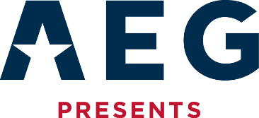
FOR MORE INFORMATION:
Sarah Wynn Benton
BRAVE Public Relations
404.233.3993
sbenton@emailbrave.com

Ben Platt Announces North American “The Honeymind Tour”
Releases new single “Cherry on Top" from highly anticipated third album “honeymind”
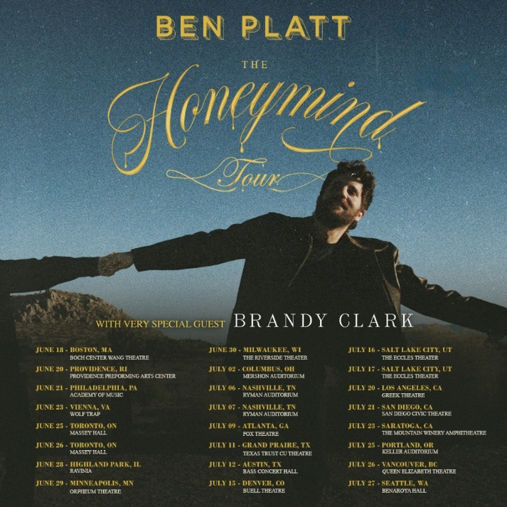
ATLANTA (April 16, 2024) – Ben Platt, Tony®, GRAMMY®, and Emmy® winner announces “The Honeymind Tour” playing across North America this summer. Kicking off July 18 in Boston and making stops at marquee venues including the Greek Theatre in Los Angeles, two nights at Ryman Auditorium in Nashville and two nights at Massey Hall in Toronto. Brandy Clark, GRAMMY® winner and songwriter for the Tony®-winning Broadway musical “Shucked,” will support on all dates. Subscribe today to receive first access to tickets at benplattmusic.com. Presale tickets are available starting Tuesday, April 16 at 10 a.m. local with all tickets available at the general on-sale Thursday, April 18 at 10 a.m. local.
Ben Platt will offer a limited number of VIP packages for his fans to take their concert experience to the next level. Packages include an amazing selection of reserved seated tickets, custom merchandise, a meet & greet with Ben and more. Visit benplattmusic.com for more info.
Along with “The Honeymind Tour” announcement, Ben Platt has also released his newest single "Cherry On Top." Produced by 9x GRAMMY® Award winner Dave Cobb, “Cherry On Top” follows last month’s release of “Andrew.” Both songs will be featured on Platt’s highly anticipated new album “Honeymind,” the platinum-selling artist’s most introspective and unfiltered project to date. “Honeymind” will be released May 31 via Interscope Records. Listen to “Cherry On Top” HERE. “Honeymind” is available now for pre-order HERE.
“I’m thrilled to be taking my show on the road! Performing my music live is what I cherish most, and I can’t wait to sing and connect with fans all over the country in such beautiful theaters and outdoors spaces,” says Ben Platt. “I especially can’t wait to sing songs from my new album Honeymind, as it’s a record I’ve been dying to perform in person. I’m beyond honored to have Brandy Clark on the road with me. We had the pleasure of writing a duet together for the upcoming album, and she is such an incredibly special artist, brilliant songwriter and icon of queer Americana.”
The North American tour will follow Platt’s exclusive concert residency at Broadway’s recently refurbished Palace Theatre. The residency, directed by Tony Award winner Michael Arden who collaborated with Platt on the 2023 Tony Award-winning revival of “Parade” which also earned Platt a Tony nomination, will play Tuesday, May 28 through Saturday, June 15 for 18 performances only. Tickets are on sale now HERE.
See below for a complete list of tour dates for Ben Platt’s North American tour. For more information, and to purchase tickets, visit www.benplattmusic.com

May 28 New York, NY The Palace Theatre
June 18 Boston, MA Boch Center Wang Theatre
June 20 Providence, RI Providence Performing Arts Center
June 21 Philadelphia, PA Academy of Music
June 23 Vienna, VA Wolf Trap
June 25 Toronto, ON Massey Hall
June 26 Toronto, ON Massey Hall
June 28 Highland Park, IL Ravinia
June 29 Minneapolis, MN Orpheum Theatre
June 30 Milwaukee, WI The Riverside Theater
July 2 Columbus, OH Mershon Auditorium
July 6 Nashville, TN Ryman Auditorium
July 7 Nashville, TN Ryman Auditorium
July 9 Atlanta, GA Fox Theatre
July 11 Grand Prairie, TX Texas Trust CU Theatre
July 12 Austin, TX Bass Concert Hall
July 15 Denver, CO Buell Theatre
July 16 Salt Lake City, UT The Eccles Theater
July 17 Salt Lake City, UT The Eccles Theater
July 20 Los Angeles, CA Greek Theatre
July 21 San Diego, CA San Diego Civic Theatre
July 23 Saratoga, CA The Mountain Winery
July 25 Portland, OR Keller Auditorium
July 26 Vancouver, BC Queen Elizabeth Theatre
July 27 Seattle, WA Benaroya Hall

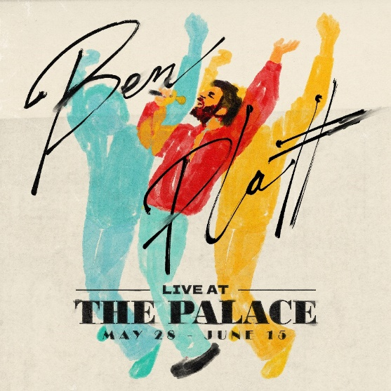
Download tour ad mats HERE.
Download hi res album art and press photos HERE.

About Ben Platt:
Tony, GRAMMY® and Emmy Award winner Ben Platt made his highly anticipated return to the New York Stage as Leo Frank in Parade at the City Center which transitioned to the Broadway stage. The riveting musical opened to rave reviews and led to Platt’s second Tony Award nomination. Most recently Ben starred in the film Theater Camp, which is co-written by Platt, Molly Gordon, Noah Galvin and Nick Lieberman inspired by their popular 2020 short film by the same name.

An accomplished recording artist, Platt has released two albums previously – 2019’s Sing To Me and 2021’s Reverie. He completed a hugely successful solo tour following the release of Reverie which saw him headlining sellout crowds at such important venues as The Hollywood Bowl, Madison Square Garden and others.

Platt won the Tony Award for Best Actor in a Musical for his groundbreaking performance as Evan in Dear Evan Hansen and later went on to reprise his role in the Universal film adaption alongside Julianne Moore and Amy Adams. Ben starred in the highly popular Netflix series by Ryan Murphy, The Politician where he served as the executive producer on the series – his performance in Season 1 earned him a Golden Globe nomination for Best Lead Actor in a Comedy Series and the show received a nomination for Best Comedy. Additionally, Platt began filming alongside Beanie Feldstein, Merrily We Roll Along which will be shot over a 20-year period, directed by Richard Linklater. Last fall, Platt was seen in the Amazon film, The People We Hate at The Wedding alongside Allison Janney and Kristen Bell. Other film and TV highlights include Pitch Perfect 1 & 2, Ricky & the Flash, The Premise and a guest appearance on Will & Grace.

About AEG Presents
Combining the power of the live event with a focus on true artist development, AEG Presents is a world leader in the music and entertainment industries. Operating across five continents, the company has an unparalleled commitment to artistry, creativity, and community. Its tentpole festivals and multi-day music events — which include the iconic Coachella Valley Music & Arts Festival and the legendary New Orleans Jazz & Heritage Festival alongside British Summer Time at Hyde Park, Stagecoach, Hangout Festival, Electric Forest, Rock En Seine and All Points East — continue to set the bar for the live music experience. AEG Presents promotes global tours for artists such as Justin Bieber, Blackpink, Kenny Chesney, Celine Dion, Elton John, Karol G, Paul McCartney, Katy Perry, The Rolling Stones, Ed Sheeran, Taylor Swift, and Tyler, The Creator, in addition to — through its network of clubs, theatres, arenas, stadiums and renowned partner brands such as The Bowery Presents, Cárdenas Marketing Network, Concerts West, Frontier Touring, Goldenvoice, Marshall Arts, Messina Touring Group, PromoWest Productions, and Zero Mile Presents — creating and developing an unmatched infrastructure for artist development and audience reach. More information can be found at www.aegpresents.com.

About the Fox Theatre
The Fox Theatre is one of Atlanta's premier venues for live entertainment, welcoming more than 250 performances a year in its 4,665-seat theatre. From concerts to ballets, comedy, and movies, the historic venue attracts more than 500,000 visitors annually. The theatre hosts over 100 annual private events like wedding receptions, trade shows, corporate meetings, and association functions in two fabulous ballrooms. The Fox’s premium Marquee Club, presented by Lexus, is a 10,000 sq. ft, three-story luxury bar accessible to all Club Level ticket holders or annual members of the Fox Theatre. As a 501(c)(3) nonprofit arts organization, the Fox Theatre stands today as a fiercely protected landmark and a nationally acclaimed theatre. The Fox Theatre proudly acknowledges its partners' generous support: Coca-Cola, Georgia Natural Gas, Georgian Terrace Hotel & Livingston Restaurant, Humana, Lexus, Northside Hospital, and Regions Bank. Tickets for all events are available at FoxTheatre.org, or toll-free at 855-285-8499. Stay connected by following the Fox Theatre on social via @theFoxTheatre on Instagram, Twitter, and Facebook.
Notable accolades include 2023 Billboard Magazine #2 Highest Grossing Theatre Worldwide (5,000 seats or less); 2023 VenuesNow Magazine #2 Year-End Top Stops (2,001-5,000 seats); 2022 IEBA Theatre of the Year; 2021 Billboard Magazine #1 Highest Grossing Theatre Worldwide (5,000 seats or less); 2021 Pollstar Magazine #2 Theatre Worldwide in Ticket Sales and 2021 VenuesNow Magazine #2 Year-End Top Stops (2,001-5,000 seats). Additionally, in 2019, the Fox Theatre was honored with the VenuesNow #1 Top Stop of the Decade Award for Tickets Sold, further cementing its reputation as a premier entertainment venue.

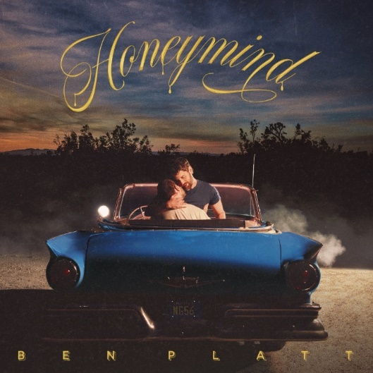
Ben Platt – “Honeymind” – Album Pre-Order
Retail: https://BenPlatt.lnk.to/Honeymind
Amazon Music Pre-Order: https://BenPlatt.lnk.to/Honeymind/amazonmusic
Apple Music Pre-Add: http://BenPlatt.lnk.to/Andrew/applemusic
Barnes & Noble: https://BenPlatt.lnk.to/Honeymind/barnesnoble
iTunes Pre-Order: https://BenPlatt.lnk.to/Honeymind/itunes
Spotify Pre-Save: https://BenPlatt.lnk.to/Honeymind/spotify
D2C Store: https://BenPlatt.lnk.to/OfficialStore

# # #

TikTok | Instagram | Spotify | Facebook

For more information on Ben Platt contact:
Christine Wolff/Christine.Wolff@umusic.com

For The Honeymind Tour:
Kristen Foster / Kristen.Foster@fullcov.com

For Live At The Palace:
Rick Miramontez/ Rick@omdkc.com
Aaron Meier/Aaron@omdkc.com

